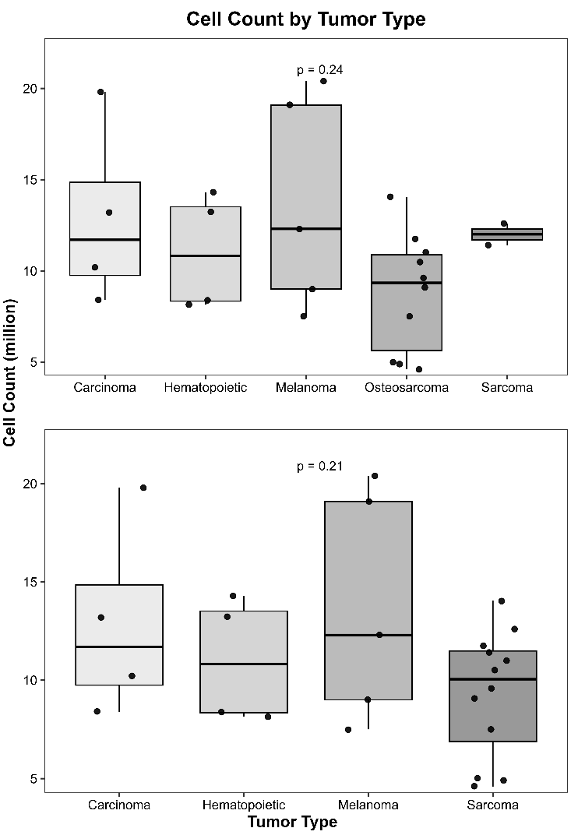
Supplementary Figure 1: Cell count by cell line tumor type. Top: five-category grouping with osteosarcoma shown separately. Bottom: four-category grouping with osteosarcoma merged into sarcoma. No differences were detected between groups (one-way analysis of variance: five-category F(4,20)=1.488, p=0.243; four-category F(3,21)=1.645, p=0.209). Points represent individual donor measurements; box plots show median and quartiles.

Supplementary Figure 2: Raw values for each analyte, color-coded by donor.

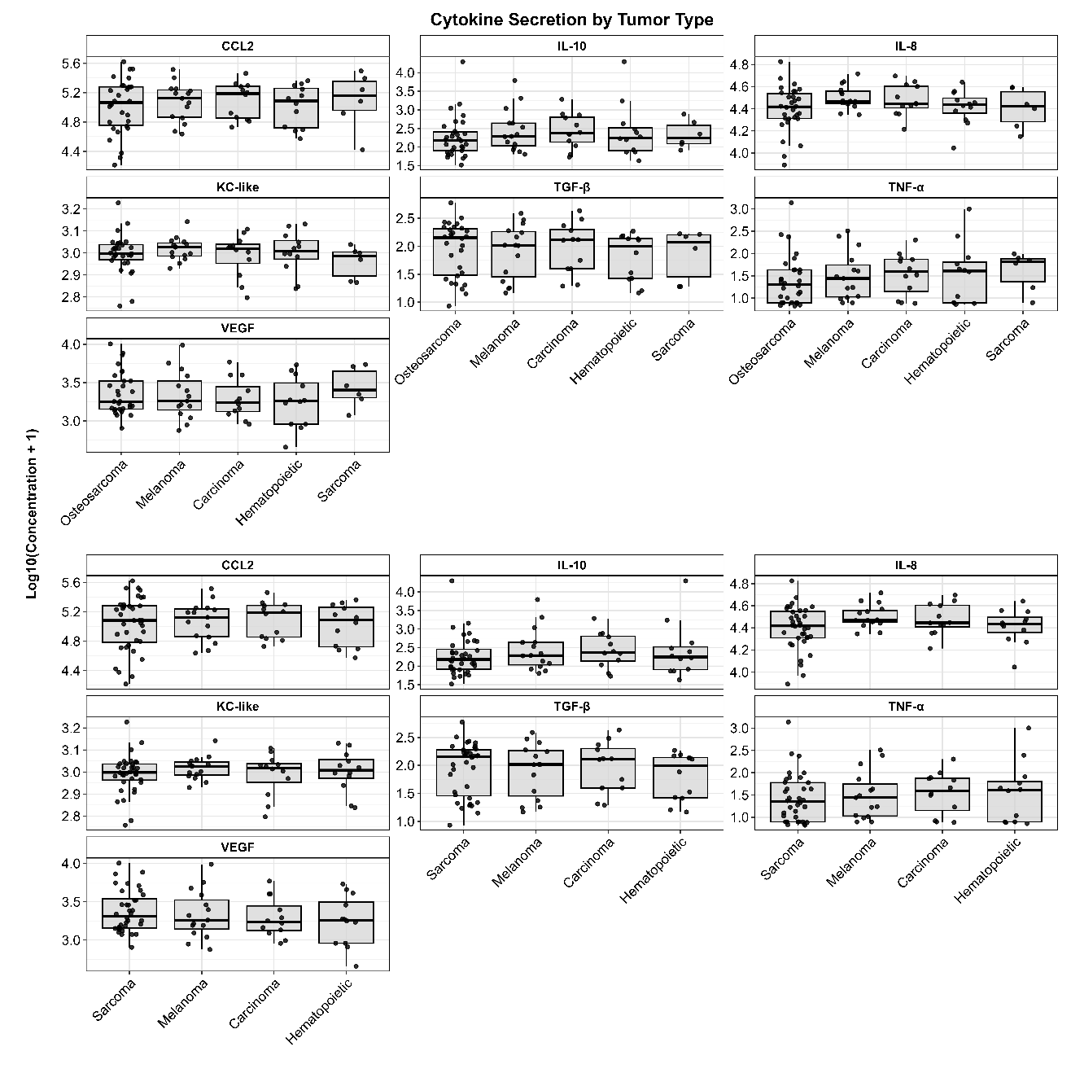
Supplementary Figure 3: Impact of tumor type on cytokine secretion. Cytokine concentrations analyzed using linear mixed models with donor as a random effect to test for differences between tumor type of the cell lines. No significant differences in cytokine stimulation were observed between tumor types in either classification system (four or five groups) after correction for multiple comparisons (Benjamini-Hochberg FDR < 0.05). Points represent individual donor measurements; box plots show median and quartiles.

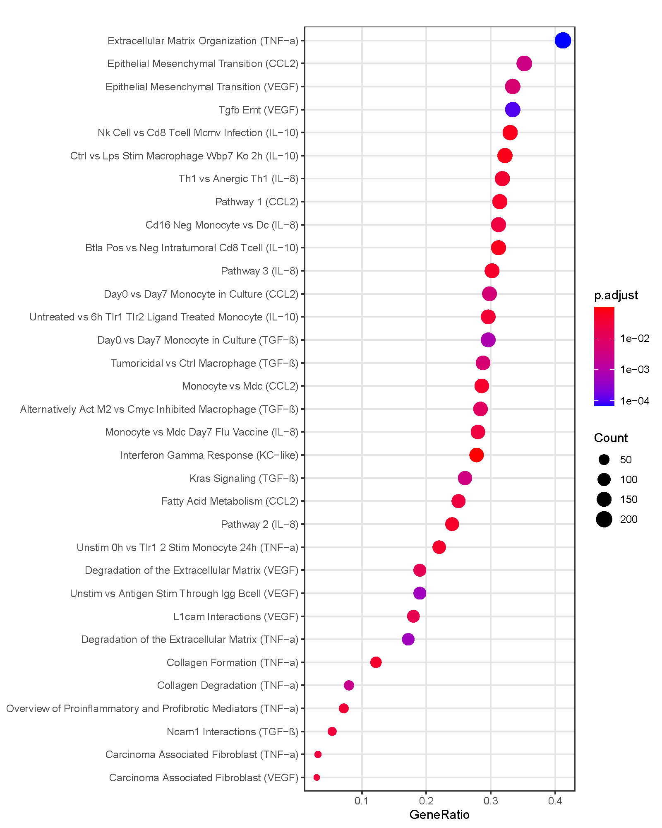
Supplementary Figure 4: Select enriched pathways across cytokines. The plot shows enriched pathways (y-axis) ordered by gene ratio, with associated cytokines listed in parentheses. Dot color indicates adjusted p-value, and dot size is proportional to gene count. Pathway names have been edited for clarity.

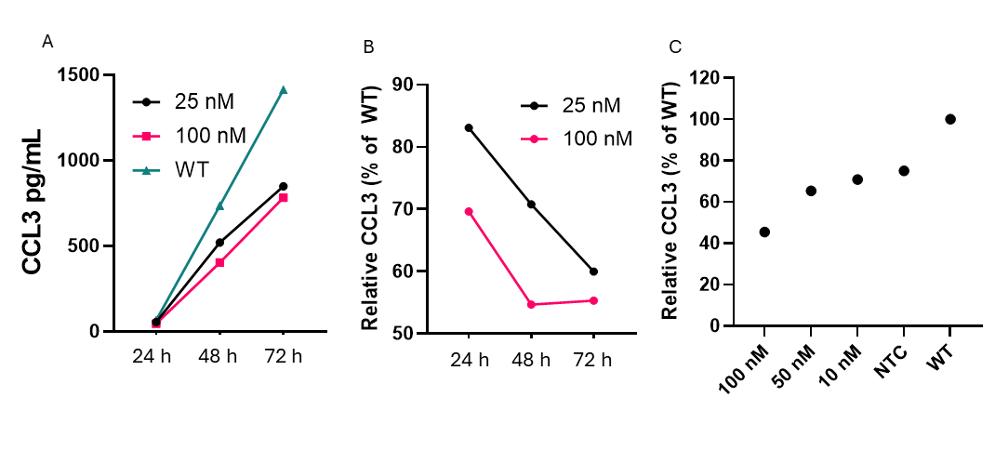
Supplementary Figure 5: CCL3 knockdown in DH82 cells. (A) Absolute CCL3 values measured by ELISA in supernatants of wildtype (WT) DH82, along with DH82 treated with 25 or 100 nM siRNA. (B) Same data as (A), showing relative CCL3 normalized to WT. X-axis for (A) and (B) is time in hours post-knockdown. (C) Densiometric quantification of western blot bands normalized to WT DH82 cells treated with either with NTC (non-targeting control siRNA) or increasing concentrations of CCL3-targeted siRNA. Lysates collected at 72 hrs.

